AI-Assisted coding(ASS-6.4)

M.sanjana

Batch-43

Ht num-2303A52292

Task 1– Student Performance Evaluation.

Write a method that displays all the student details using the class attributes. The method should print the name, roll number, and marks in a clear format. Then create another method that compares the student’s marks with the class average. Use an if-else condition to decide whether the student is above or below average. Return a meaningful message based on this comparison. 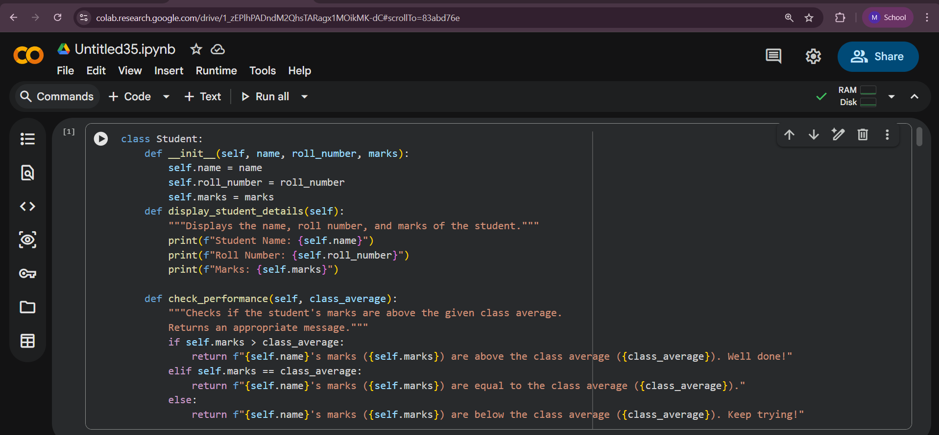
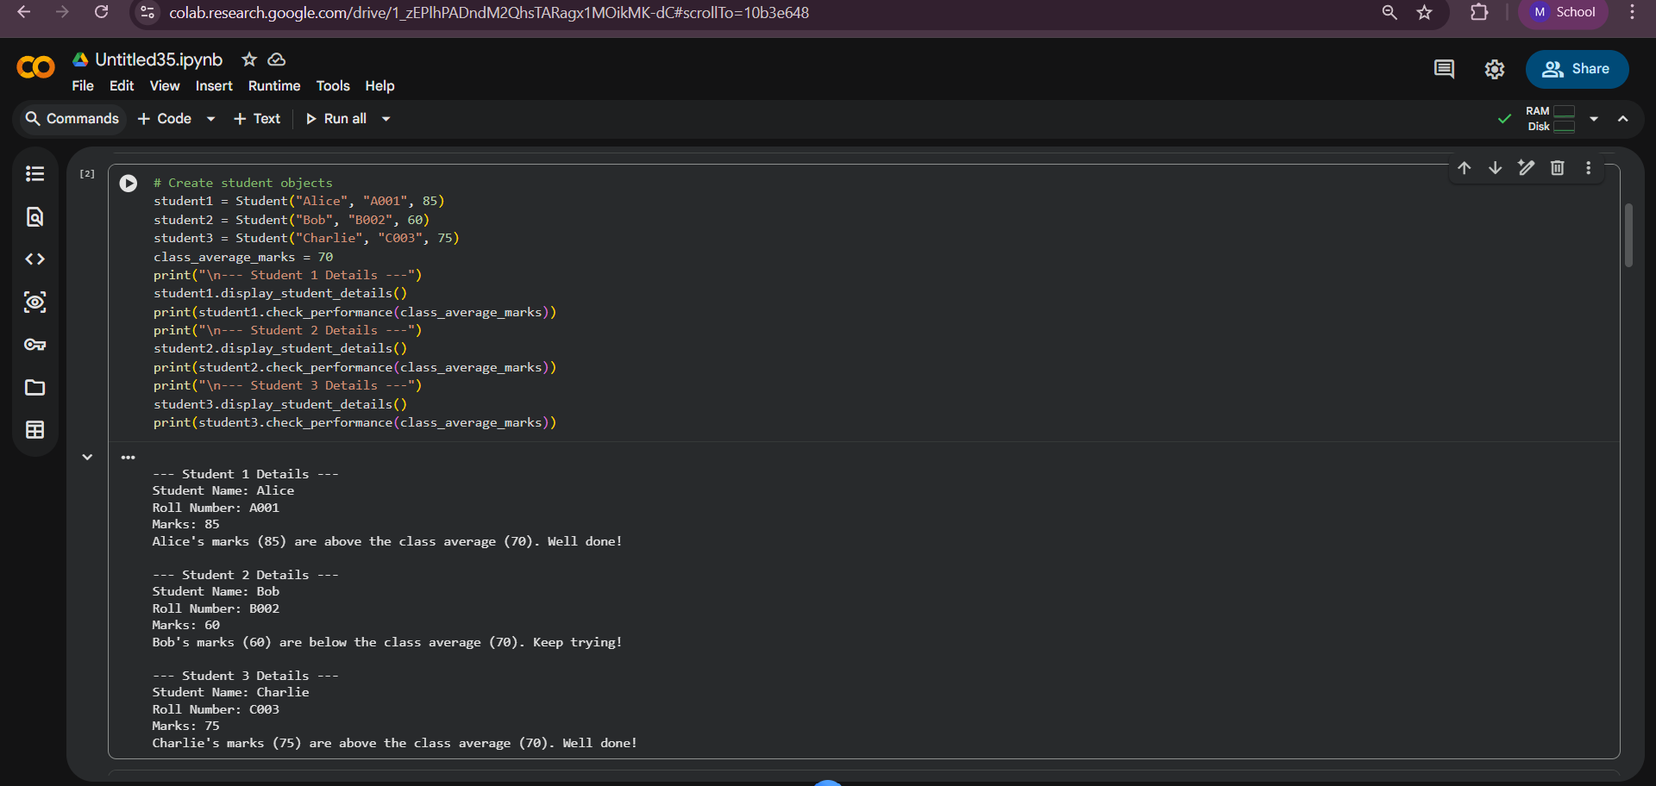

Task 2– DataProcessing in Monitoring System.
Inside the loop, add logic to identify whether the current number is even by using the modulus operator. If the number is even, calculate its square value. Print both the number and its square in a readable format. Make sure odd numbers are ignored. Use proper conditional statements to control the flow

OUTPUT:

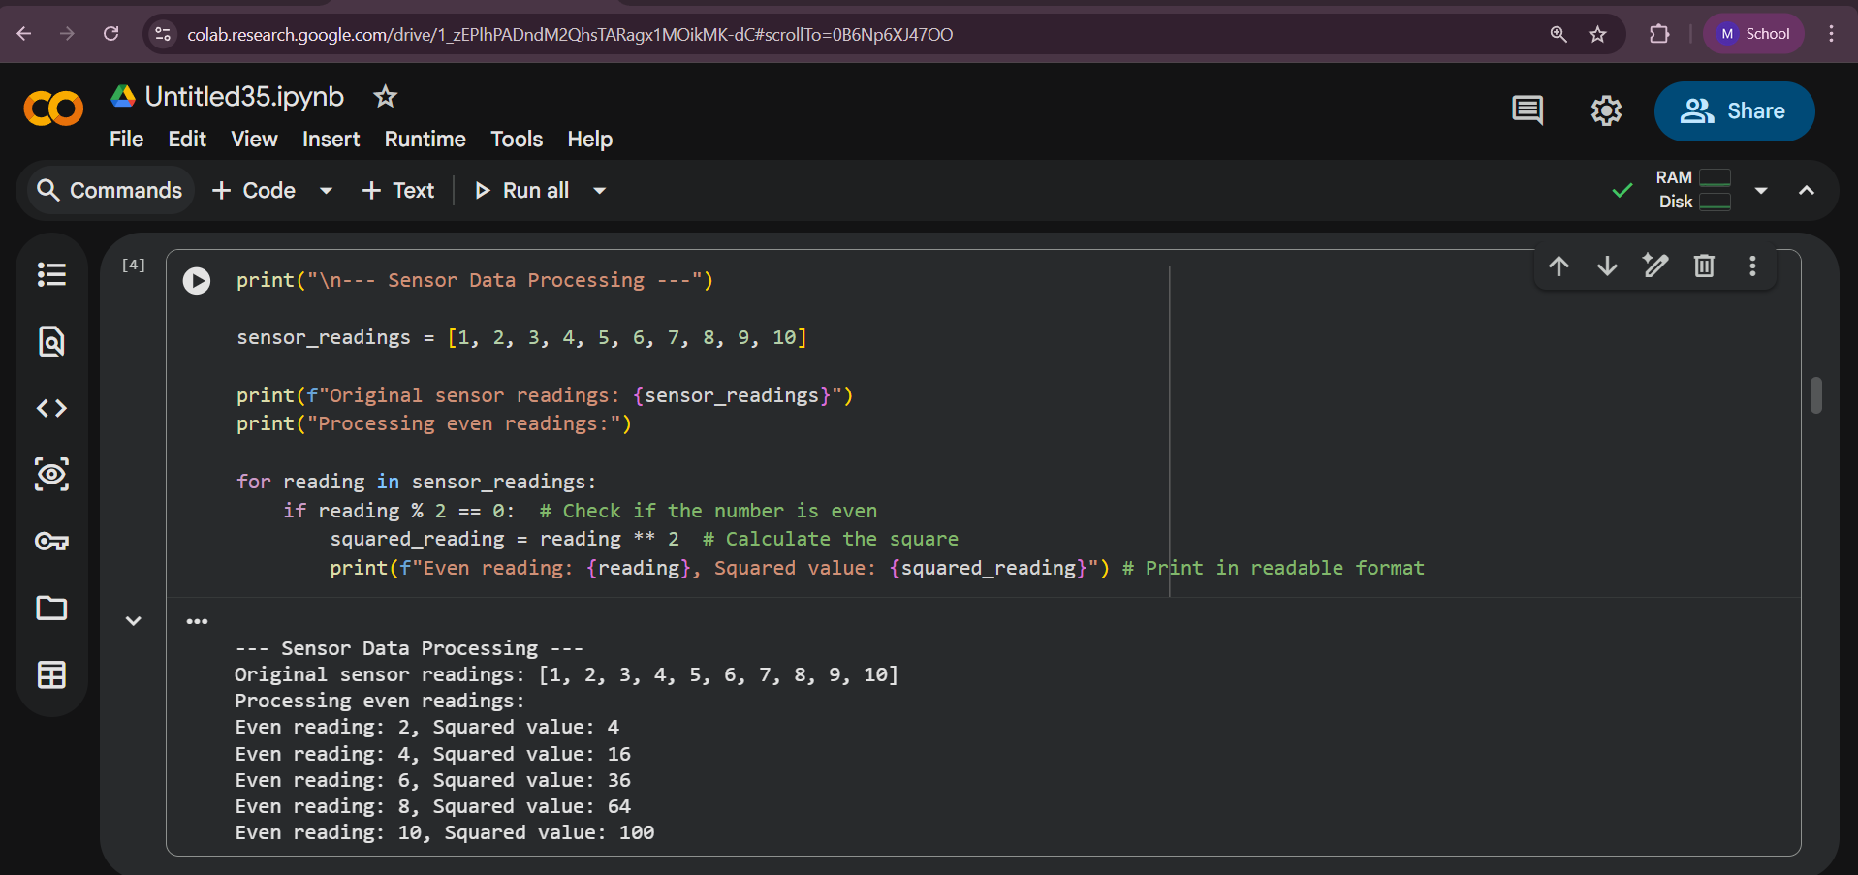

Task 3: Banking Transaction Simulation

Create a deposit method that increases the account balance by the given amount. Also write a withdraw method that deducts money from the balance. Use an if-else condition to prevent withdrawal if the balance is insufficient. Display user-friendly messages after each transaction. Access all data using the class attributes with self.
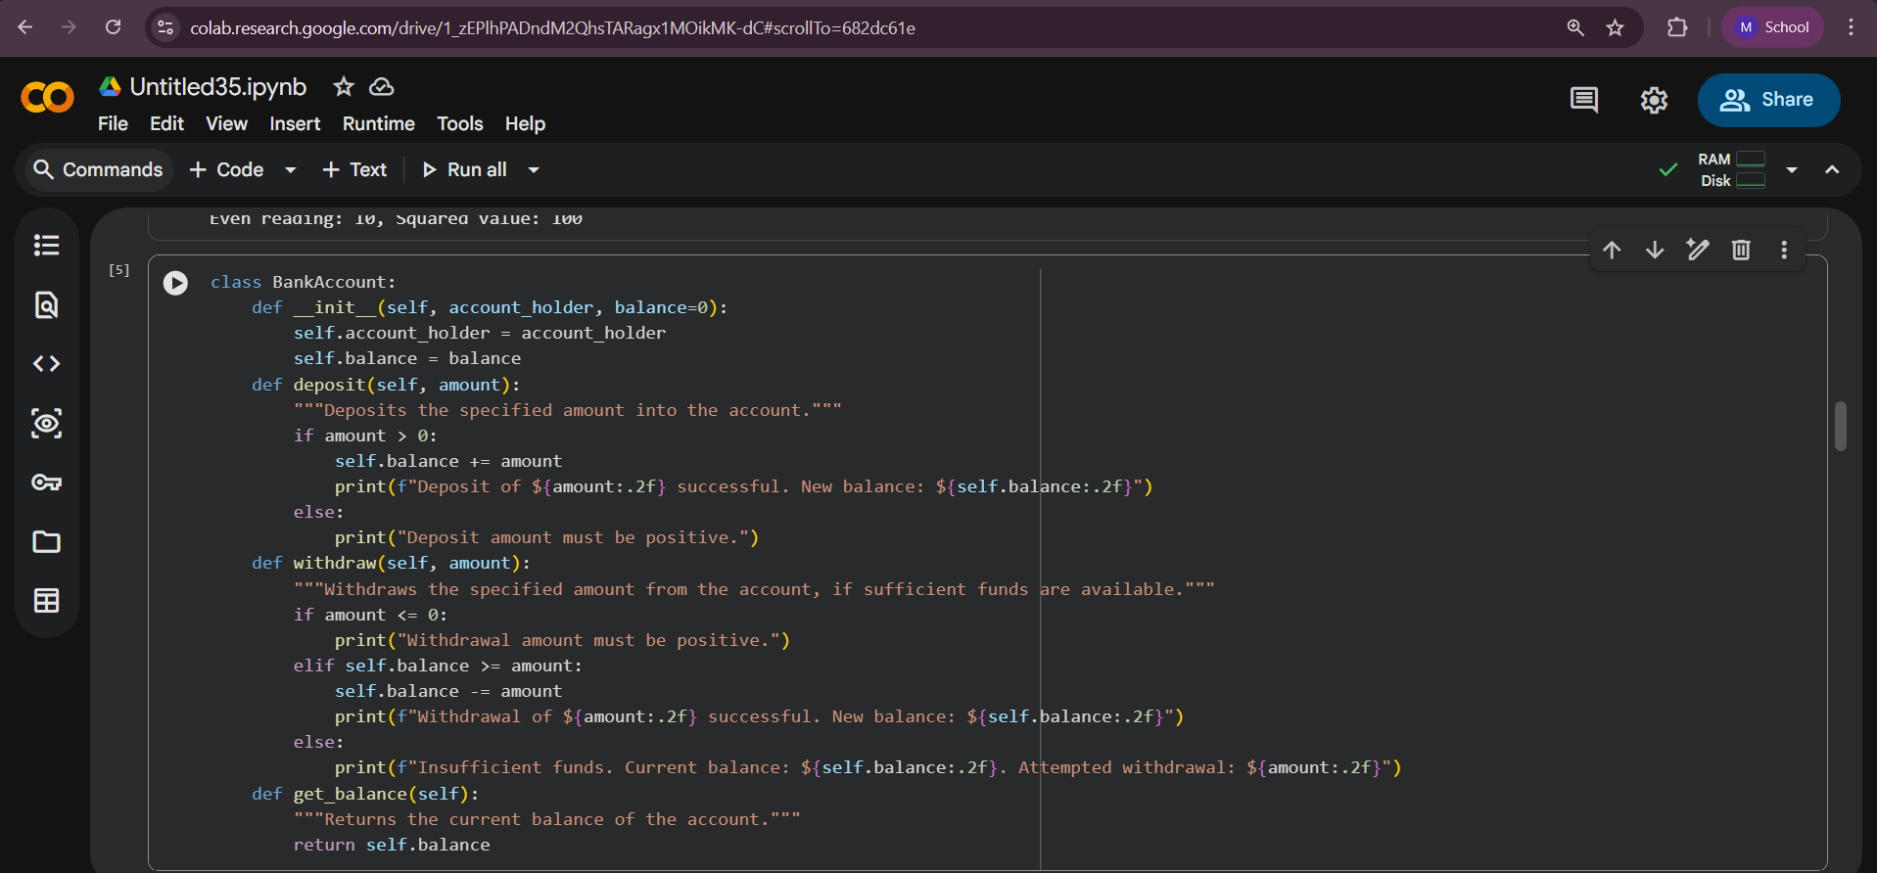

Output:

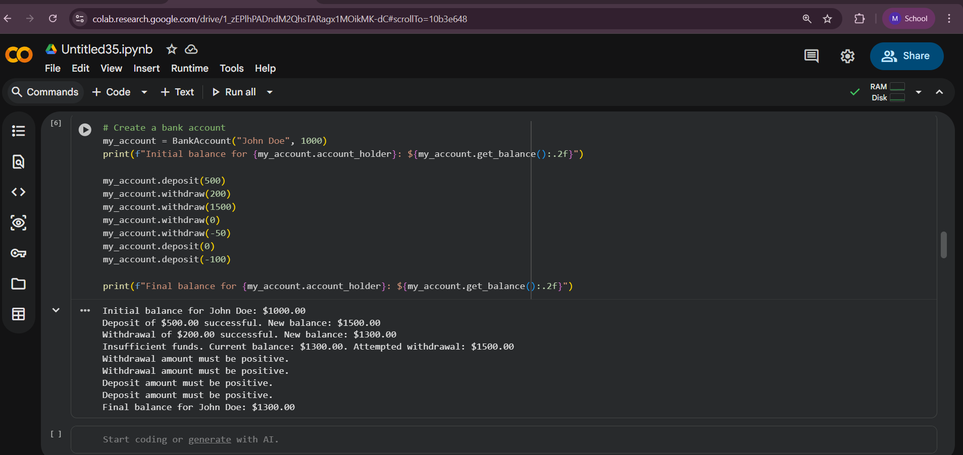

Task 4: Student Scholarship Eligibility Check

Write a while loop that iterates through the list of student dictionaries using an index. Access each student’s score and check if it is greater than 75. If the condition is satisfied, print the student’s name as eligible for the scholarship. Ensure proper index increment and loop control. Format the output neatly
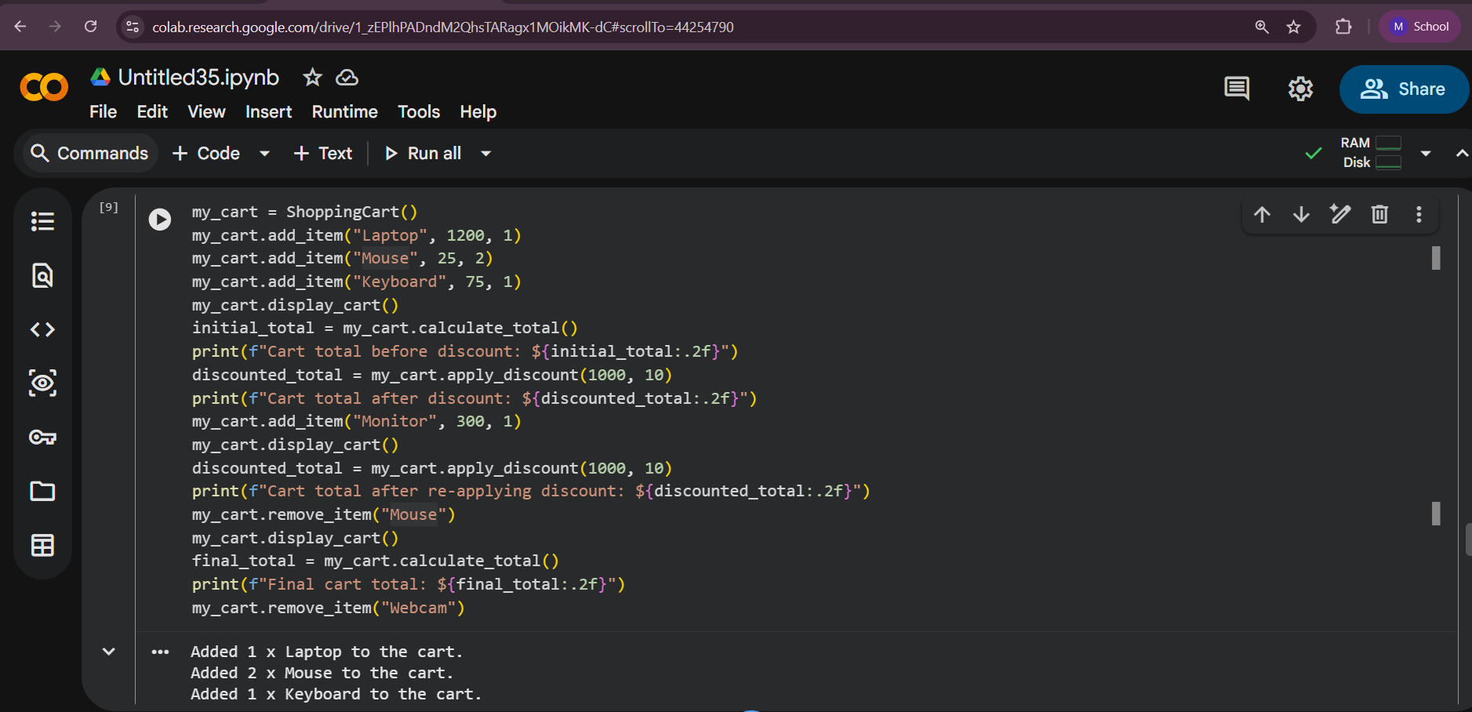

Output:

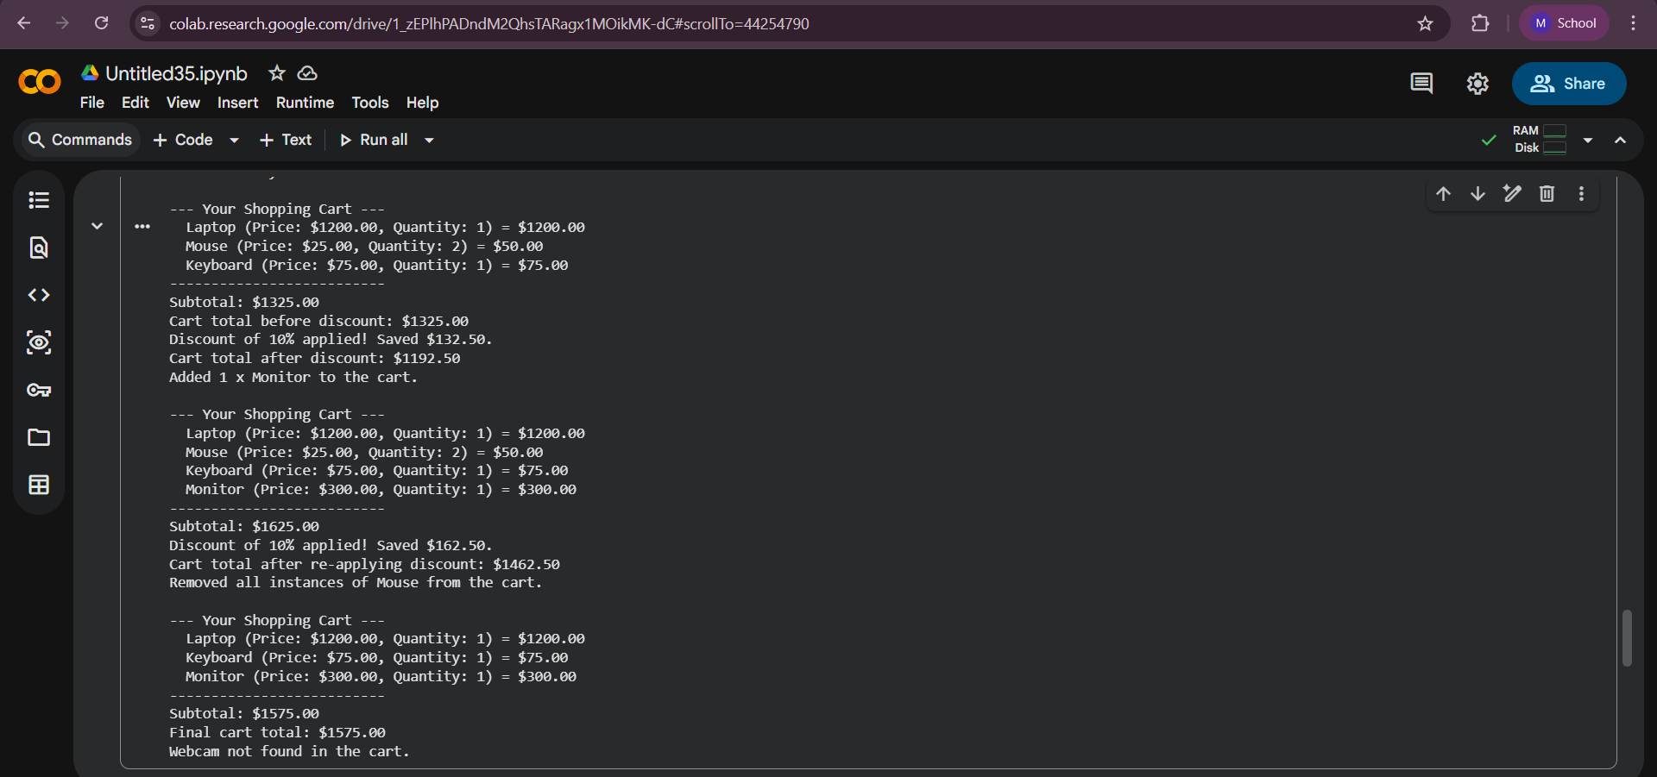

Task 5: Online Shopping Cart Module

Develop methods to add items to the cart and remove items from it. Use a loop to calculate the total bill by multiplying price and quantity of each item. Add a condition to apply a discount if the total exceeds a specific limit. Return the final bill amount after discount. Make sure to use class attributes and conditional logic correctly
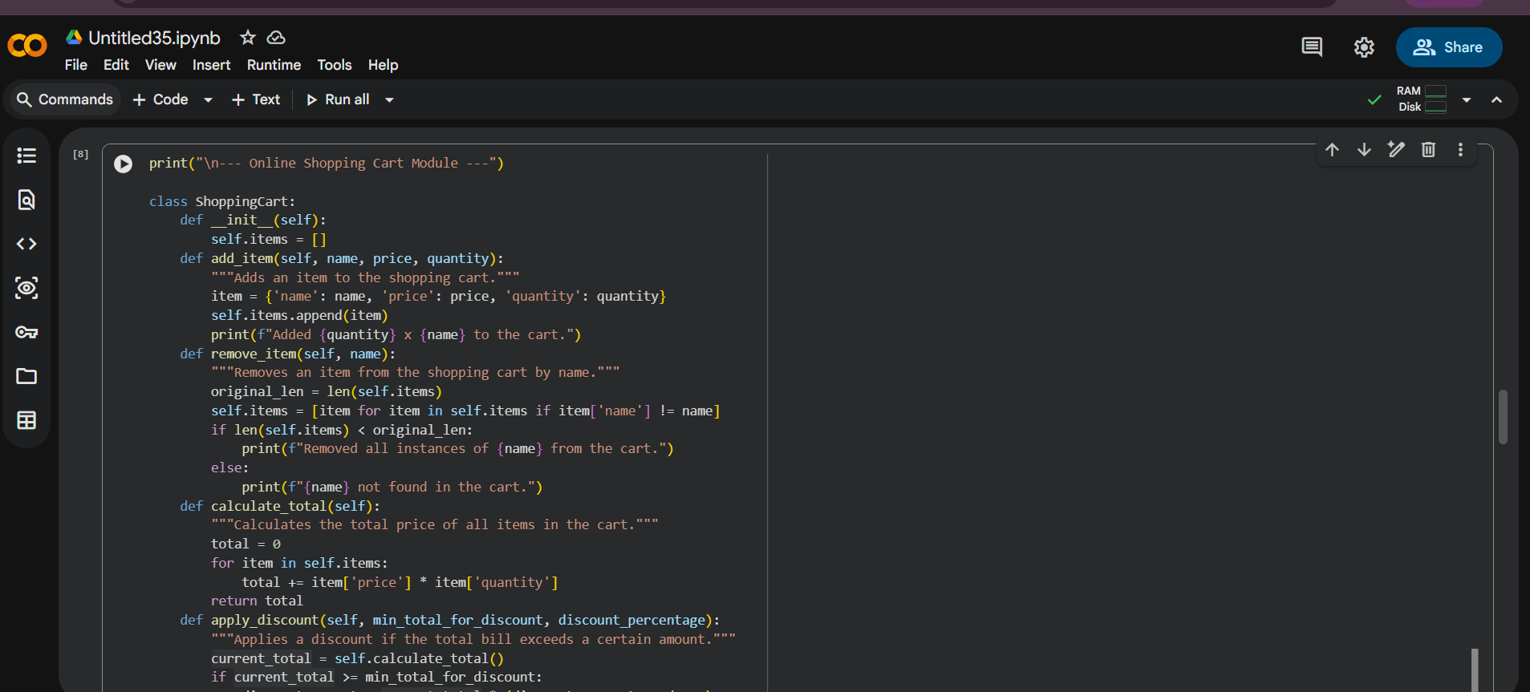
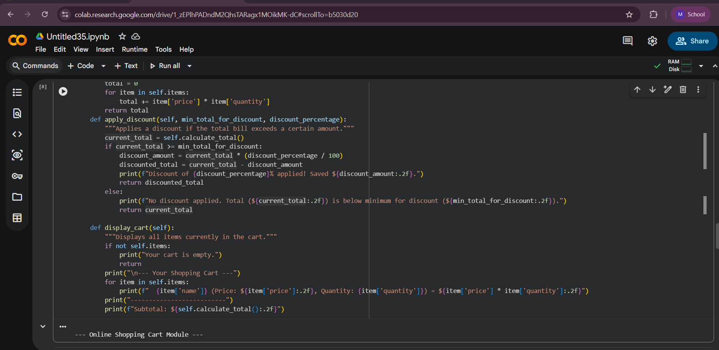
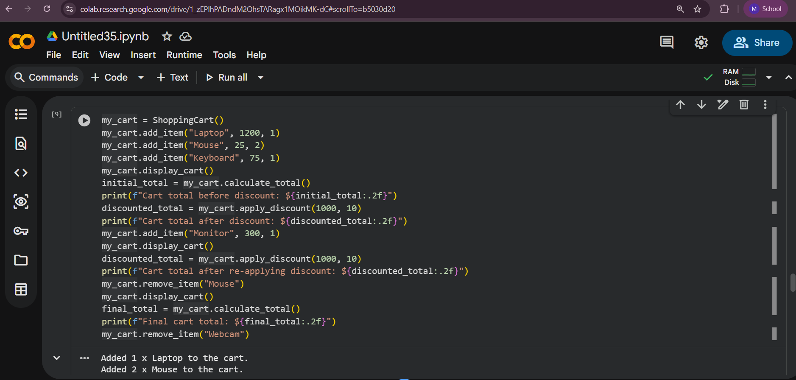

Output:
